
Design Doc Light (DDL)
PriceCheck Web Service
Main Developer | Slee | PM | jeannek |  | Test
Spec URL | file://bel-pfs-01/ProdDev/ENAPrograms/Specs/Dynamic%20Pricing%20And%20Text%20Specification.doc
URL to This File | \\bel-pfs-01\ProdDev\ENAPrograms\DesignDocs\PriceCheck DDL.doc
Project Central ID |  | Target Release |  |  | Target Date
Last Saved | January 24, 2008 - 9:46 PM by Sandra Lee

Intent

Note: This DDL is intended to elaborate upon a specific component of the Dynamic Text and Pricing solution. Please see \\bel-pfs-01\ProdDev\ENAPrograms\DesignDocs\Dynamic Text and Pricing DDL.doc for the overall dev design documentation.

The PriceCheck module is an ASP.Net web service which retrieves and returns the lowest cached price (originally obtained from from OPI) for Flight, Package, and Hotel deals.

Note: There is a requirement to include support for additional data sources (such as TravelHook) in the future.

Solution

Create and deploy an ASP.Net Web Service which caches price data originally obtained from OPI.

The project will comprise a web service (ASMX) application to be deployed on the webserver within the daily tree (example: http://www.expedia.com/daily/home/PriceCheck --> http://www.expedia.com/PriceCheck). The web service will be a wrapper which references a class library to handle the caching and lookup functionality.

The class library will contain three “layers” or sets of classes:
- Cache classes to store the data.
- Request-and-cache layer to make the OPI requests (or import the XML) and update the cache as needed.
- Lookup classes which are called by the web service method to retrieve the requested data from the cache.

Cached Data:

Price data will be stored in three separate cached SortedLists (one for each LOB). The origin and destination data will also be stored in cached SortedLists.

The cached SortedLists will each have a cache dependency upon a single external XML file. These lists will be removed and recreated each time the linked file changes. Callback functions will be used to serialize the XML data into the cached SortedLists.

If possible, the price data will be denormalized to simplify lookups. If we determine that denormalization requires too much memory, the Lookup layer can access the cached DMA mapping table to obtain the Origin and Destination names, but this will increase CPU usage.

Example:
Flight Cache:
Origin  (DMA – int) | Origin Name  (string est. 26 bytes) | Destination  (string - 13 bytes) | Destination Name  (string est. 26 bytes) | DateRange  (int) | Price**  (int) | Status  (char) | TimeStamp  (DateTime)
11111 | Metropolis | DEF | Gotham City | 1 | 223 |  | ---
33333 | Gotham City | ABC | Metropolis | 2 | 223 |  | ---
33333 | Gotham City | NYC | New York City | 1 | 420 |  | ---
** If no acceptable price is found, price will be null but the row will be stored in the cache. This is to prevent repeated requests to OPI for non-existent pricing.

Back-end processes:

The Origin and Destination data will be maintained in XML files and propped as needed. (In the future, this data may be stored in the Atlas database and retrieved via a .vbs script.)

The XML files containing the Hotel and Package price data will be created via a .vbs script which makes calls to OPI (to be initiated via a scheduled task on the server).

If necessary, these scripts will force a delay between calls to avoid overwhelming the OPI/Travelservers.

Should the backend processes be stored on Belwaweb01 or Expresso3?

Worst-case estimated memory usage:

Flights: **worst-case (ads targeting all origins to all destinations) is unlikely to happen
102 Origins x 137 Destinations = 13,974 OandDs
13,974 OandDs x 7 DateRanges = 97,818 rows
97,818 rows x 86 bytes = 8,412,348 bytes = 8,216 Kb + overhead

Flights (Origin only) – stored in flights cache w/ empty destination
102 Origins x 7 DateRanges = 714 rows
714 rows x 47 bytes = 33,558 bytes = 33 Kb + overhead

Packages:
40 Origins x 30 Destinations = 1200 OandDs
1200 OandDs x 3 DateRanges = 3600 rows
3600 rows x 78 bytes = 280,800 bytes = 275 Kb + overhead

Hotels (no Origin data):
30 Destinations x 3 DateRanges = 90 rows
90 rows x 52 bytes = 4,680 bytes = 5 Kb + overhead

Origin DMA to TLA Map:
DMA  int | DMA Name  string (est. avg. 26 bytes) | TLA  string (13 bytes)
11111 | Metropolis | ABC
33333 | Gotham City | DEF
33333 | Gotham City | GHI

Each row contains 43 bytes
Rough estimate 102 rows
102 rows x 43 bytes = 5 Kb + overhead

Destinations:
Region Package Name  string (est. avg. 26 bytes) | TLA  string (13 bytes)
Metropolis | ABC
Gotham City | DEF
Gotham City | GHI
Each row contains 39 bytes
Rough estimate 137 rows
137 rows x 39 bytes = 6 Kb + overhead

Estimated total memory usage for application cache:
8,540 Kb + overhead or roughly 8.5 MB of server memory (worst-case)

Cached classes:
All 5 caches will be stored in stored as sorted lists (System.Collections.Generic.SortedList) of class objects.

Flight class:
String OriginDma
String OriginName
String DestinationTla
String DestinationName
Int DateRange
Int Price
Char Status
DateTime TimeStamp

Package class:
String OriginDma
String OriginName
String DestinationTla
String DestinationName
Int DateRange
Int Price

Hotel class:
String DestinationTla
String DestinationName
Int DateRange
Int Price

Request-and-cache classes:
There are two possible implementations under consideration for retrieving data from OPI.
- The preferred method (if feasible) is to query OPI directly for a deal if it is not found in the appropriate cache, then store the results in the cache for future use.
  - Pros: This design allows for a great deal of flexibility going forward. The web service would not be dependent upon an external job and replications for current pricing, which means fewer points of failure.
  - Cons: The total number of OPI calls will be multiplied by the number of web servers in use. Jeanne is checking with travprod to see whether there is another place this can go which would involve fewer servers but could handle the load.
- The alternative method is to use a backend process to query OPI at defined intervals, store the results in a set of XML files (at least one per LOB), and push the files out to the live site. The cache will be linked to these XML files and will automatically refresh when the file changes. The caches will have just-in-case expiration times to ensure that old prices are not returned if the current file has not changed (i.e., if the back-end job breaks or replications are down).
  - Pros: The impact to OPI will not vary with the number of web servers.
  - Cons: This solution will make it more difficult to accommodate changes. All possible queries LOB/Orig/Dest/DateRange must be made up front, regardless of whether the data will be used. The web service would be dependent upon an external job and replications for current pricing.

A tentative decision has been made to use a combination of these two solutions:

- Flights will be requested directly from OPI (and stored in the cache) as there will be very little impact to the travel servers.
- Hotels and packages will be retrieved via a backend process, which will be designed to distribute the requests over an hour (or other time-period) rather than making them all at once. These will be stored in the cache.
In all cases, the data will still be stored in the web service cache, so that the front-end classes which obtain and return the data to the user will not be tied to a specific source. This approach will miminize the changes required if we add other data sources such as TravelHook.

OPILoader class:
This class uses the Expedia framework OPI objects to make flight calls as needed and store the lowest price in the cache. Called by the GetFlightPrice method of the Lookup object.
Methods:
- public int GetFlight(Orig, DateRange) – Gets lowest-priced OPI flight for the specified origin.
- public int GetFlight(Orig, Dest, DateRange) – Gets lowest price for the OandD pair

Note: To cut down on the number of OPI calls, these methods may package up to 10 rules (with different destinations in one call) and store the results for all of them. A configuration variable in web.config will control the number of calls made.

LobLoader class:
This class is called by the Package and Hotel cache dependency callback functions.
Methods:
- LoadPackageData() -- Removes the old package data from the cache and serializes new package XML data into a new LinkedList.
- LoadHotelData() -- Removes the old hotel data from the cache and serializes new package XML data into a new LinkedList.

Dynamic OPI call details:
- A timestamp (8 bytes) and a char status code (2 bytes) will be added to each row of the cache. The timestamp will be used to determine whether the price is out of date. The expiration period is specified on a per-LOB basis in web.config.
- At intervals specified in the web.config file, the entire LOB cache will be flushed so that prices which are no longer in use will be cleared. (Example: once per day at 2am.)
- In order to prevent a repeat of the same request before the data can be stored, each time an OPI query is performed the record will be created (if necessary) and given a status code of “P” (pending). Subsequent requests for that data will pause briefly (# of milliseconds TBD) to allow the request to complete and try again (# of tries TBD).
- If no price is found, a record will be stored in the cache with a null price value to indicate that a request has already been made.
- If an OPI request fails, the record will be treated as though no price was returned.

Configuration data, including cache timeouts (per LOB) and minimum star rating will be kept in web.config, which can easily be modified to change these parameters as needed.

Estimated impact to OPI:
Note: Accurate estimates are not possible until we have the origin and destination data.

Estimate for per-hour impact to OPI (per web server if using dynamic OPI requests), is as follows;
- Flights:
  - 102 Origins x 7 DateRanges x 4 sets of rules (10 dests each) = 2856 flight queries
  - 8 sets of rules (10 TLAs each) x 8 DateRanges = 64 Origin-only flight queries
- Packages:
  - 40 Origins x 2 TLAs (est. avg.) x 30 Destinations x 3 DateRanges = 7200 OandD package queries
- Hotels:
  - 30 Destinations x 3 DateRanges = 90 Hotel queries

For all servers (assumption: 60 webservers):

- Flights (10 rules per request):
  - 1,920 flight queries x 60 = 115,200 requests per hour (dynamic)
  - 64 Origin-only flight queries x 60 = 3,840 requests per hour (dynamic)
- Alternative: Flights (as needed – no bundling of rules)
  - Depends on ad requirements, but may not be much more than the bundled requests.
- Packages:
  - 7200 OandD requests per hour (back-end)
- Hotels:
  - 90 requests per hour (back-end)

For the backend process, these requests will be performed once per hour, but will not be per-server.

Lookup class:

This class will be called directly by the web service methods to request and return data from the cache objects.

Methods:
- public int GetFlightPrice(Orig, Dest, DateRange, MaxPrice) – returns price
- public int GetPackagePrice (Orig, Dest, DateRange, MaxPrice) – returns price
- public int GetHotelPrice(Dest, DateRange, MaxPrice) – returns price
- public int GetLobCache(LOB) – returns a LinkedList from the cache

Web Service:

The web service will return an object with the return data values as properties. This is automatically formatted as SOAP/XML in the response.

Example request:
<?xml version="1.0" encoding="utf-8"?>
<soap:Envelope xmlns:xsi="http://www.w3.org/2001/XMLSchema-instance" xmlns:xsd="http://www.w3.org/2001/XMLSchema" xmlns:soap="http://schemas.xmlsoap.org/soap/envelope/">
<soap:Body>
<GetDestinationPrice xmlns="http://tempuri.org/">
<LOB>string</LOB>
<Orig>string</Orig>
<Dest>string</Dest>
<DateRange>int</DateRange>
</GetDestinationPrice>
</soap:Body>
</soap:Envelope>

Example response:
<?xml version="1.0" encoding="utf-8"?>
<soap:Envelope xmlns:xsi="http://www.w3.org/2001/XMLSchema-instance" xmlns:xsd="http://www.w3.org/2001/XMLSchema" xmlns:soap="http://schemas.xmlsoap.org/soap/envelope/">
<soap:Body>
<GetDestinationPriceResponse xmlns="http://tempuri.org/">
<GetDestinationPriceResult>
<Price>string</Price>
<Origin>string</Origin>
<Destination>string</Destination>
<FriendlyOrigin>string</FriendlyOrigin>
<FriendlyDestination>string</FriendlyDestination>
<LOB>string</LOB>
<StartDate>string</StartDate>
<EndDate>string</EndDate>
<Error>string</Error>
</GetDestinationPriceResult>
</GetDestinationPriceResponse>
</soap:Body>
</soap:Envelope>

Database Interaction

For now, the Origin and Destination mapping data will be stored in an XML file and kept in VSS. The file will be updated manually and propped as needed. (In the future, this data may be stored and maintained in the Atlas database, but this work is out of scope for this project.)

The following processes are dependent on this data:
- DoubleClick interface
- Back-end process to retrieve Package and Hotel pricing data.
- The PriceCheck web service in production

Design metadata

Using existing code:

Most of the EURO .Net code is not applicable to this project; however, there are existing classes for creating and parsing OPI requests which may prove very helpful here.

By inheriting the Expedia.Web.Core.ExpediaWebService base class, which is already available in /daily/home/bin, we should have access to all of these classes without a lot of extra work to integrate with the .Net platform.

Additionally, all code should conform to the guidelines found at:
http://expedia/flexwiki/default.aspx/Expedia.WebDev.CodingConventions

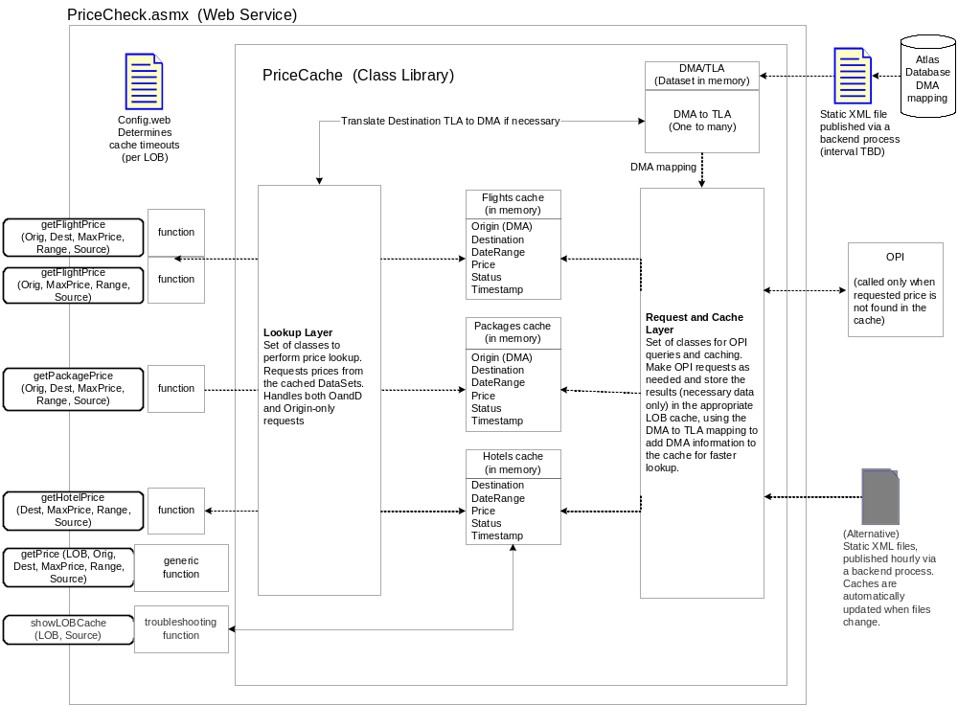

Configuration/Debugging

Configuration

All global configuration settings (timeouts, retry parameters, etc., minimum star rating, etc.) will be stored in web.config.

Debugging/Testing

How will you troubleshoot this in production?
The webservice will include a troubleshooting function which will return a dump of an LOB cache, so that we can see the current data, status, and timestamps. This should give us a good idea of what’s going on within the application.

How is this feature turned on? (if relevant)
A configuration variable in web.config will turn off pricing – the web service will return an empty SOAP response. This feature may also be turned off by deactiving the ads which use it or removing the price requirement from the ads.

Testing will need to spoof IP addresses in order to verify that origins are being used properly.

Rollout Plans

- When is this shipping?
- Is this customer-facing?
- Will we need new hardware?
- How will we turn this on?
- Can we turn the feature off in production if there’s an emergency? How?

All of this is explained above or in the spec. The project schedule has not yet been determined.

The web service will live in the daily tree and will be
Example:
http://www.expedia.com/daily/ws/PriceCheck.asmx

Need to determine directory structure

Misc. Checklist
For each, provide an answer and justification for non-obvious cases.
Does the feature need:

Architect Review? N/A

Stress testing? Stress testing will be needed for this project. Tester will need to simulate the large number and variety of web service requests. Both the test webserver and the OPI test server should be monitored for performance.

Localization? N/A

Integration Testing? N/A

Logging? N/A

What other project dependencies are there?

Copy this issue box to anywhere in the doc, then fill it out. Don’t forget to update the issues block at the bottom of this doc.

Issues
Issue: Can we access the Yukon cache directly, bypassing OPI? 2
Issue: Need to determine directory structure 3

Notes

Stuff the spec should track – make sure it’s covered there
Stage gates/checkpoints
Ship times

